My plan for this assignment was to calculate the total cost of the cleaning service by dividing houses into 3 groups based on the number of rooms, and then adding the cost for each service. I also included some ways to catch invalid inputs and future proofing with easy ways to add more cleaning options, although it can be further improved because my calculators don’t account for more future cleaning options, just the user inputs. Additionally, I’ve scaled my calculators to adjust for very big homes, as mansions shouldn’t cost the same amount to clean as large homes.

The design of my project was to have 3 functions. I have one function that takes user input for requested services and checks them against a preloaded array of acceptable values to make sure the user isn’t inputting any services we don’t offer. If the user does input services we don’t offer, this function should force the user to re input acceptable options. The next function calculates total value of cleaning based on services requested and room types. This function is divided into 3 different options for house sizes, and has an extreme case exception for very large houses. This function has to add costs for every cleaning service requested should the customer want more than one.  
  
my three test cases for my test plan will be invalid room number inputs (non integer values), invalid services requested, and a thoroughness check to make sure all of the possible options together work as expected.

First test case invalid room numbers:  
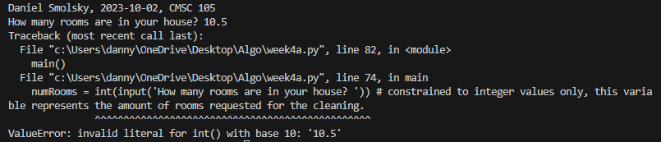

Second test case invalid services:

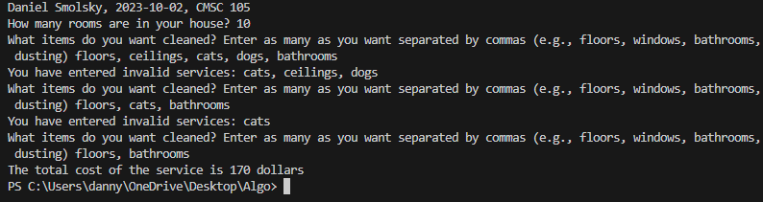

Third test case: everything working as expected:

